Rent Freeze Twitter assets
Scroll down to see Twitter handles you can paste into your tweets
Suggested text and images.
H4A Rent Freeze Day of Action page https://tinyurl.com/RentFreezeAction

Image | Text | Main hashtag  #RentFreezeNow #ServiceChargeFreeze #StopEvictions  #FundRepairs
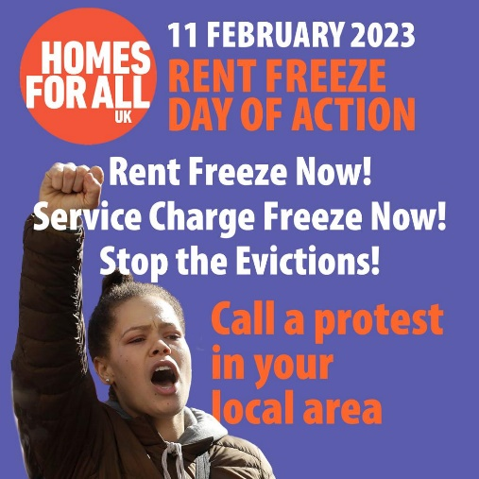 | #RentFreezeNow Day of Action  Sat 11 Feb, 12pm, Dept Levelling Up, SW1P 4DF  Join us in London or call a protest in your local area.  #ServiceChargeFreeze #StopEvictions  #FundRepairs  https://tinyurl.com/RentFreezeAction | #RentFreezeNow
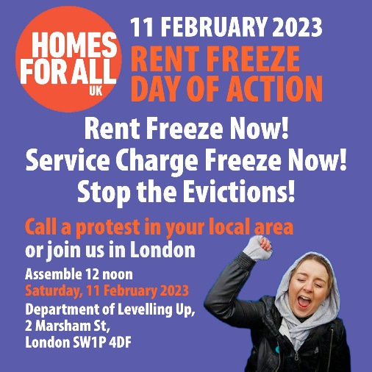 | Wages and benefits haven’t kept pace with inflation.  We can’t afford a rent rise!  #RentFreezeNow Day of Action  Sat 11 Feb, 12pm.  Dept Levelling Up, SW1P 4DF  #ServiceChargeFreeze #StopEvictions  #FundRepairs  https://tinyurl.com/RentFreezeAction | #RentFreezeNow

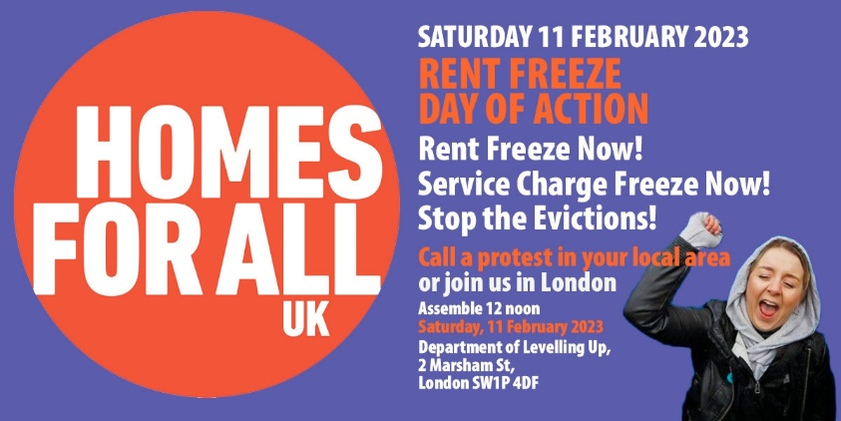 | #RentFreezeNow day of action Sat 11 Feb, 12pm  Dept Levelling Up, SW1P 4DF  Service charges are rising with inflation, but wages and benefits are not. Tenants and #leaseholders demand a #ServiceChargeFreeze now!  #StopEvictions  #FundRepairs  https://tinyurl.com/RentFreezeAction | #ServiceChargeFreeze
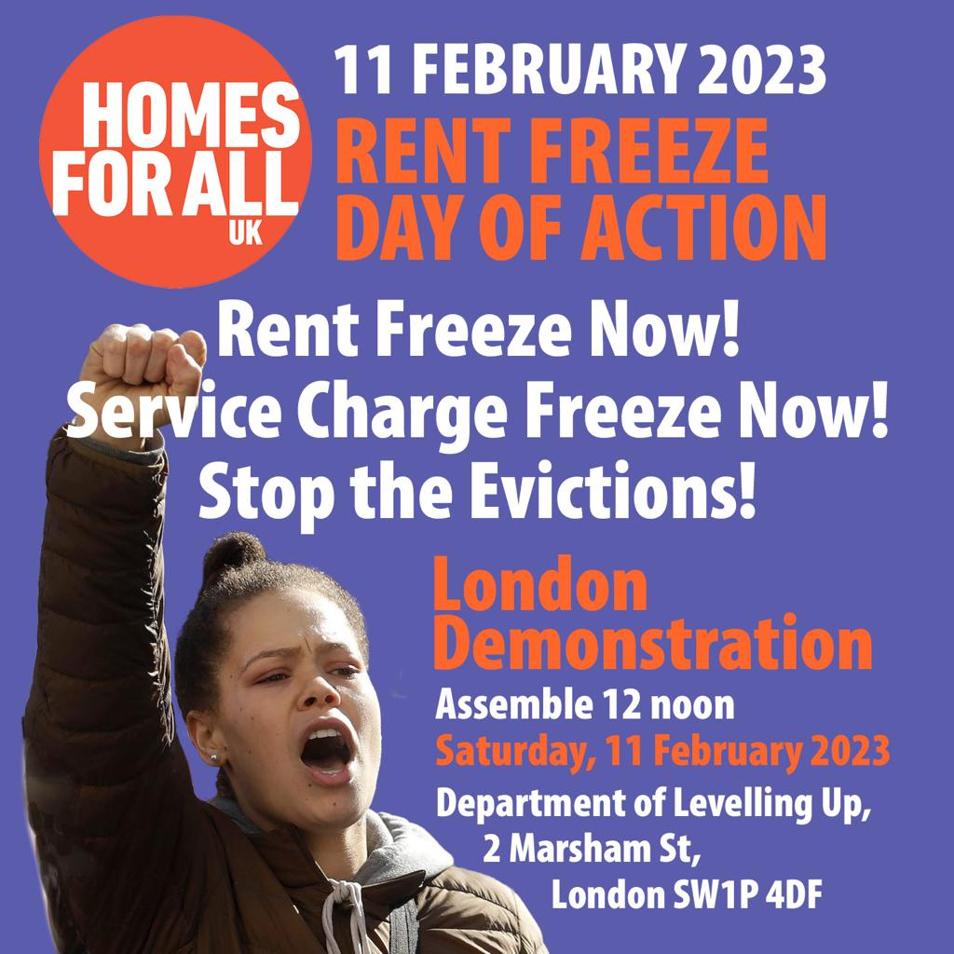 | Unaffordable rents are forcing people onto the streets. Homelessness is growing.  We demand #StopEvictions  Join the Rent freeze day of action  Sat 11 Feb, 12pm  Dept Levelling Up, SW1P 4DF  #RentFreezeNow #ServiceChargeFreeze  #FundRepairs  https://tinyurl.com/RentFreezeAction | #StopEvictions
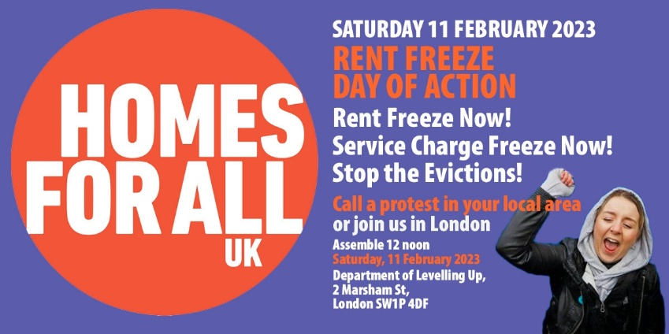 | Councils are raising rents, cutting repairs, building fewer homes.  Govt. should fund councils properly.  Councils – unite with tenants to demand a funded #RentFreezeNow  Day of Action – 11 Feb  #ServiceChargeFreeze #StopEvictions  #FundRepairs  https://tinyurl.com/RentFreezeAction | #FundRepairs

Pick 2 or 3 handles to add to your tweet

In H4A or Rent Freeze action group
@Homes4AllUK
@NEF
@LDNRentersUnion
@emptyhomes
@diarmaid_w
@Living_Rent
@IslingtonH4All
@FuelPovAction
@ValerieABossman
@MoyraSamuels
@HAWRNet
@Muna_Suz
@LondonRenters_
@SLRenters
@DCHCampaign
@rentstrikeUoM
@VivaViva70
DPAC - @Dis_PPL_Protest
@HaringeyHousing
@partridgebirdie
@GrenfellUnited
@labour_council

Other housing groups/movements
@extortionbyclad
@THRenters
@lambethrenters
@LondonRentCap
@LondonTenants
@Radical_Housing
@Advice4renters
@Fight4Aylesbury
@acorn_sheffield@ACORNunion
@SaveCressingham
@WF_Renters
@radicalhousing
@Councilhomechat
@_HSG_
@genrentuk
@TBTCLondon
@Hackney_renters
@HouSolidarity

Other campaigns, groups, media, people likely to be supportive
@dontpayuk
@PEACH_E16
@ourcityRTTC
@pplsassembly
@PricedOutUk
@crosstowns
@SouthwarkNotes
@TheCanaryUK
@streetskitchen
@PeopleBeforeProfit
@worker_group
@insidehousing
@We_Ownit
@camdenactiongrp
John Bird @johnbirdswords
@fenwick_place
@sianberry
@MelReesHerman
@GulcinOzdemir11
@EOCS_Official
@Idemamba
@Plan4Holloway
@ReclaimStreets
@chakrabortty

Officials that need to know
@MayorofLondon
@tomcopley

Unions
@UniteHousing
@unitetheunion
@unisonPress1
@UniteCommunity1
@NASUWT
@UniteSharon
@cyclingkev

